Interactive Drawing Recognition App
  - Machine Learning Project Report
Goobin Jung | November 5 2026

Project purpose
I built Draw & Guess, a web app that recognizes five hand-drawn objects: cat, car, tree, umbrella, and clock. A user draws on a canvas and clicks Guess. The app displays three ranked predictions with a confidence score for each, as requested by my instructor. The saved model achieved 95.13% accuracy on a separate test set of 1,500 drawings.
I chose this project because a user can test the model directly with a new drawing. The result is easy to see, which makes the project suitable for a short live demonstration. The work combines model training, image processing, a working web interface, and evaluation.

Technology choices
I used PyTorch to define the CNN and write the training loop. TensorFlow/Keras could also support this task. I chose PyTorch because its explicit training steps let me inspect the loss, update the model, and save its learned weights. This was a design choice; I did not run a performance comparison between frameworks.
A small CNN fits the 28 by 28 grayscale input and the five-category task. Its convolution layers learn local patterns such as lines and shapes. Keeping the network small also allowed training on CPU. I chose Flask because the trained model could stay in Python while HTML and JavaScript handled drawing in the browser. PyCharm was my development environment, and uv recorded the Python dependencies.

Data preparation
I used the NumPy bitmap files from Google's Quick, Draw! dataset [1]. I chose Quick, Draw! because its simple sketches match the drawings users make in the app. MNIST focuses on digits, so it does not match my five object categories. The preparation script selected 2,000 images per category with random seed 42. It skipped blank images and excluded exact duplicate pixel images across the selected set. The 10,000 selected images were divided as follows.
Split | Per category | Total images
Training | 1,400 | 7,000
Validation | 300 | 1,500
Test | 300 | 1,500

Training data updated the model. Validation data selected the saved checkpoint. Test data were kept separate until the final evaluation. Images were reshaped to 28 by 28 and their pixel values were scaled from 0–255 to 0–1.

Model and training
The CNN takes one 28 by 28 grayscale image. Two convolution blocks use 3 by 3 filters, 16 and 32 channels, ReLU, and max pooling. A 64-unit layer leads to five output scores. Training uses cross-entropy loss; prediction uses softmax.
Optimizer | Learning rate | Batch size | Epochs
Adam | 0.001 | 64 | 10

CPU training used seed 42. Validation accuracy rose from 89.47% to 95.07% at epoch 6. Epoch 10 matched that accuracy, so the earlier checkpoint was kept. Final training accuracy was 97.63%. The weights, class names, and epoch were saved in drawing_cnn.pt using PyTorch's state_dict method [2].

Connecting the model to the app
The browser sends a PNG drawing to the Flask /predict route. The server converts it to white lines on black, crops it, preserves its proportions while resizing, and centers it in a 28 by 28 image. Pixel values are scaled to 0–1. The model returns three predictions. Flask loads the page from templates/index.html [3].
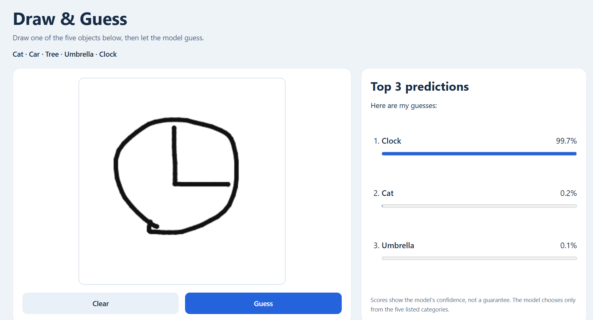
Figure 1. An app-drawn clock ranked first with a displayed confidence score of 99.7%.

Evaluation results
I evaluated the saved epoch 6 model without updating its weights. Top-1 accuracy means the first prediction is correct. Top-3 accuracy means the correct category appears anywhere among the three predictions.
Evaluation | Images | Top-1 accuracy | Top-3 accuracy
Quick, Draw! test | 1,500 | 95.13%  1,427 correct | 99.47%  1,492 included
Manual app drawings | 25 | 100%  25 correct | 100%  25 included

Each category had 300 test images and five manual drawings. Recall measures the share of actual images in a category that were correctly identified. The manual confidence column is an average of the rounded scores displayed in the screenshots.
Category | Test recall | Manual correct | Mean manual confidence
Cat | 92.00% | 5/5 | 64.78%
Car | 96.33% | 5/5 | 58.90%
Tree | 92.33% | 5/5 | 90.54%
Umbrella | 96.00% | 5/5 | 92.14%
Clock | 99.00% | 5/5 | 97.20%

Errors and confidence
The test set contained 73 incorrect predictions. The largest confusion was cat predicted as car in 16 cases, followed by car predicted as cat in 10 cases. Trees were predicted as cats nine times and as umbrellas nine times. These counts show where the saved model had difficulty.
Confidence did not always match correctness. One recorded test error was a car predicted as cat with 96.97% confidence. In the manual sample, car4 was correctly ranked first with only 47.2%, ahead of cat at 30.2%. A score below 50% can still be the highest among five categories. These scores have not been calibrated as probabilities of being correct.

Limits of the manual evaluation
All 25 manual examples were ranked correctly, and screenshots were saved for each result. However, this was a small set and several drawings had similar styles. It does not establish 100% accuracy for different users or arbitrary drawings. The manual and dataset evaluations used different samples and are reported separately.

Problems and solutions
The first web page showed an Internal Server Error because index.html had not been created. I added the file in the templates folder next to app.py, and the page then loaded correctly.
GitHub Push also failed when an older 32-bit Git helper crashed. I installed a current 64-bit Git version and changed PyCharm's Git executable path. Push then succeeded. The local commits were preserved.
The first interface left too much empty space. I expanded the layout and canvas. Enlarging the canvas also made the lines look too thick, so I reduced the brush setting from 12 to 6 and added a brush-shaped cursor. After HTML changes, restarting Flask and refreshing the browser made the updates visible.
I used separate GitHub commits for environment setup, data preparation, the model, training, evaluation, the app, manual results, and the README. This history records the actual development steps [4].

What I learned
Working through this project helped me understand why training, validation, and test data have different roles. Training accuracy alone does not show how the model handles new inputs. Validation selected the checkpoint, while the separate test set measured its final performance.
My main lesson was the difference between accuracy and confidence. Accuracy measures how often the model is correct across a set of examples. Confidence is a score for one prediction. A high score can be wrong, and the highest score can be below 50% in a five-category task. I learned to report accuracy with the sample size and to explain confidence as a model score.

Future improvements
I would test more varied drawings from different users and record more failure examples. I would also compare preprocessing choices using validation data. The app currently always selects from five categories, so a future version could handle unsupported drawings. Confidence calibration would be another useful study. These changes would need new evaluation.

References and evidence
1. Google Creative Lab. The Quick, Draw! Dataset.
2. PyTorch. Saving and Loading Models.
3. Pallets. Flask Quickstart.
4. Goobin Jung. Project code, commits, and recorded results.
The Quick, Draw! dataset is made available by Google, Inc. under the Creative Commons Attribution 4.0 International license. Detailed training history, test metrics, and the 25 manual screenshots are stored in the repository.

